# +Creating a bot using the Microsoft Bot Framework In C#

# Hands-on Lab Manual

Table of Contents

+Creating a bot using the Microsoft Bot Framework In C# 1

Hands-on Lab Manual 1

Lab Introduction 3

Objectives 3

Prerequisites 3

Lab Scenarios 3

Configuration and Setup 4

Copy/Paste of Code 9

Exercise 1: Basic Bot using BotBuilder 10

Exercise 2: Creating Dialogs 16

Exercise 3: Form Flow 26

Exercise 4: Using Intent Dialogs (LUIS) 41

Additional Resources 48

Copyright 49

## Lab Introduction

|  |  |
| --- | --- |
| Objectives | After completing these self-paced labs, you will be able to:   * Have an understanding of the basics of the Bot Framework |
| Prerequisites | * Visual Studio 2015 (community edition or other editions) * NGrok * Bot Application Template * Basic understanding of C# |
| Lab Scenarios | This series of exercises is designed to show you how to get started using the Microsoft Bot Framework. In this lab, we are going to create a DinnerBot that will allow you to make reservations for a restaurant. |

### Configuration and Setup

1. Install prerequisite software
   * **Visual Studio 2015** : <https://www.visualstudio.com/vs/community/>
   * **NGrok** : <https://ngrok.com/>   
     **Skype** : <http://skype.com> (if you want to test a Skype Bot)
   * **C# Bot Application Template**: <http://aka.ms/bf-bc-vstemplate> When this zip is downloaded, copy (not unzipped) to %USERPROFILE%\Documents\Visual Studio 2015\Templates\ProjectTemplates\Visual C#
   * **Update all Visual Studio Extensions (Tools 🡪 Extensions and Updates 🡪Updates)**
   * **Bot Framework Emulator:**  <https://docs.botframework.com/en-us/downloads/>
   * **Create a Microsoft ID** (if you don’t already have one)

Go to the Microsoft account sign-up page <https://account.microsoft.com/> and **click** **Create account**.   
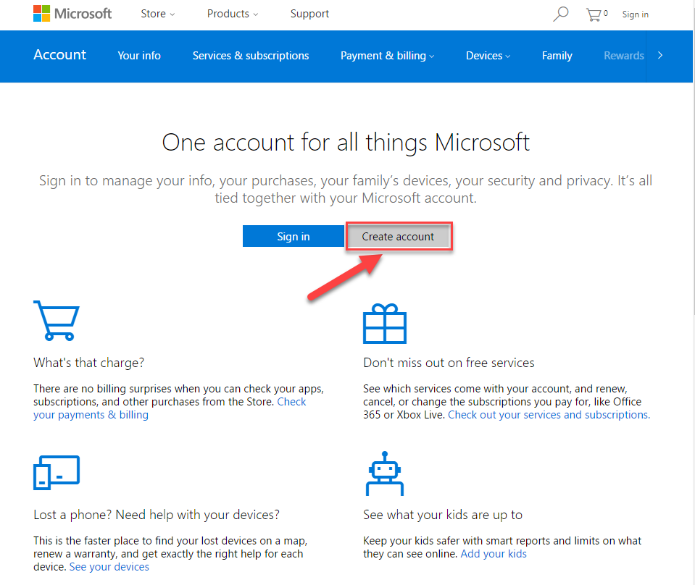

* + In the User name box enter your existing email address, or click Get a new email address to create an Outlook or Hotmail address.   
      
    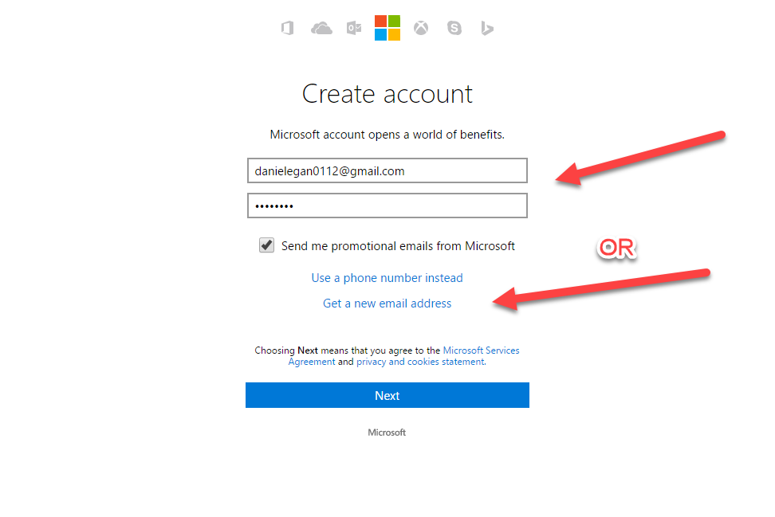  
    **NOTE**: **If you use an existing email address you will need to verify it before moving on.**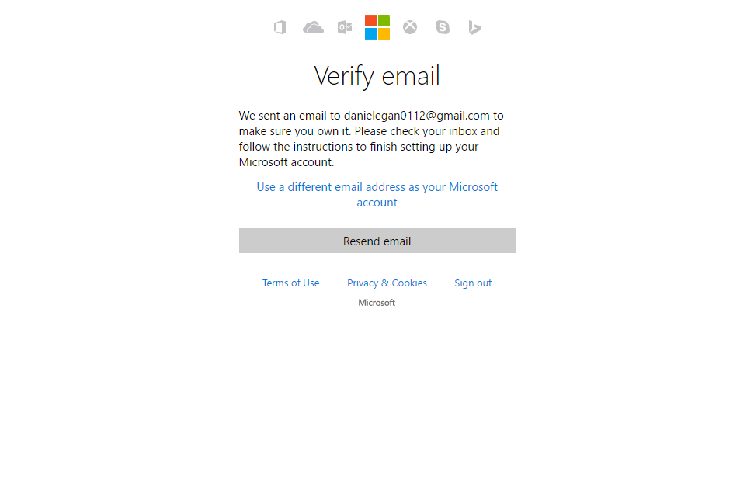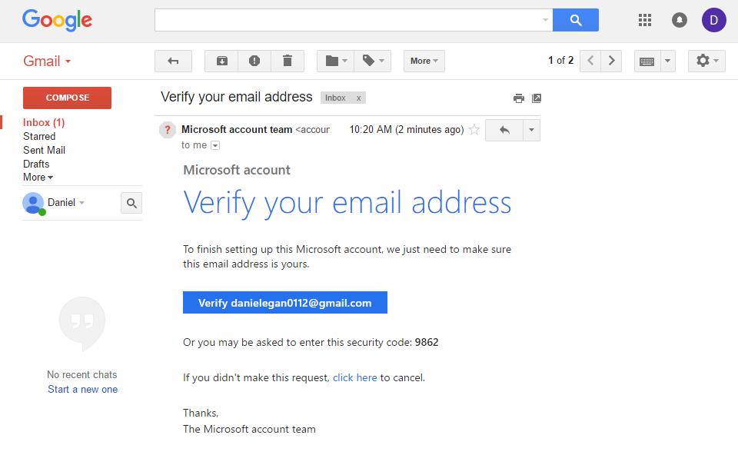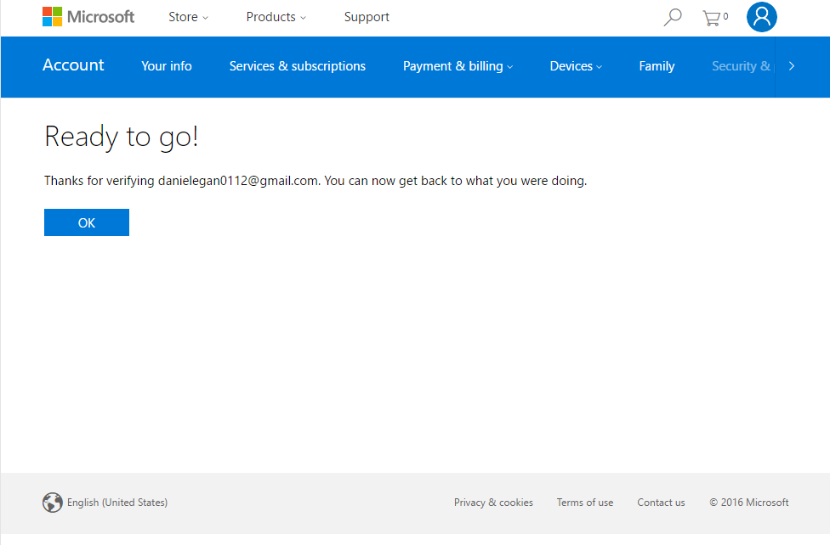
  + Either path will take you to this screen  
      
    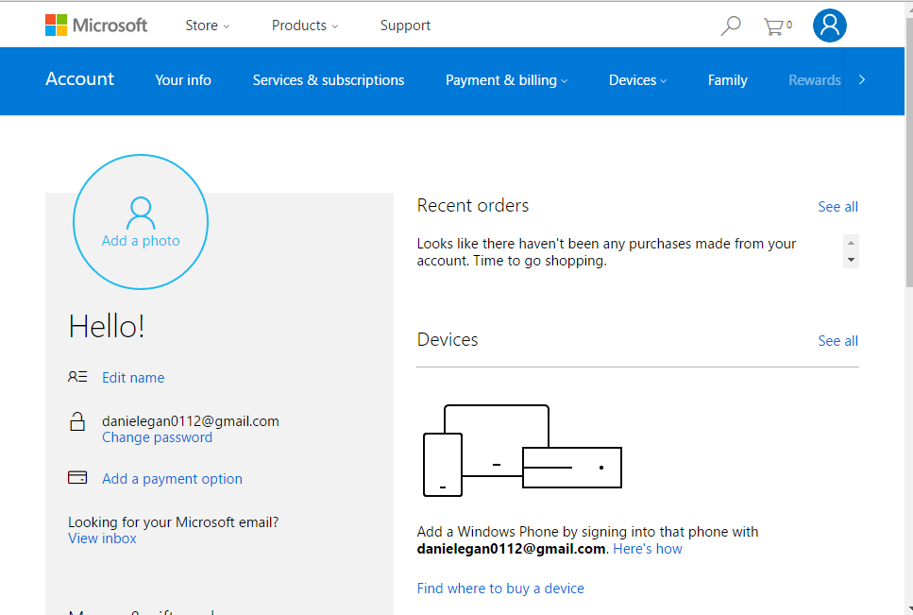

1. Create a BotFramework account
   * Navigate to <http://BotFramework.com>
   * Click on sign in  
       
     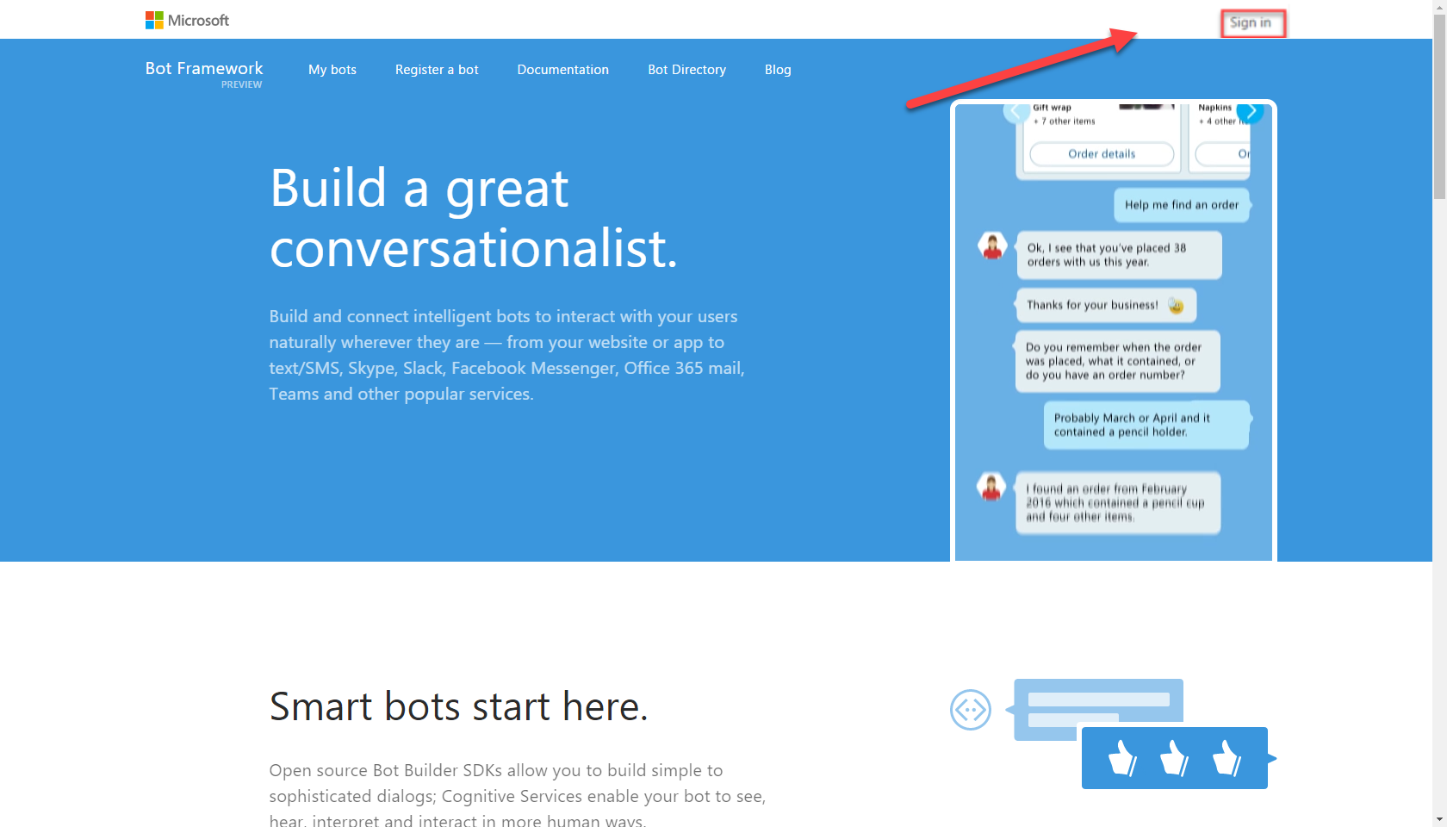
   * If you are using the same browser that you used to create your Microsoft ID then you will be signed in automatically, otherwise you will need to use the ID you just created to sign in.   
       
     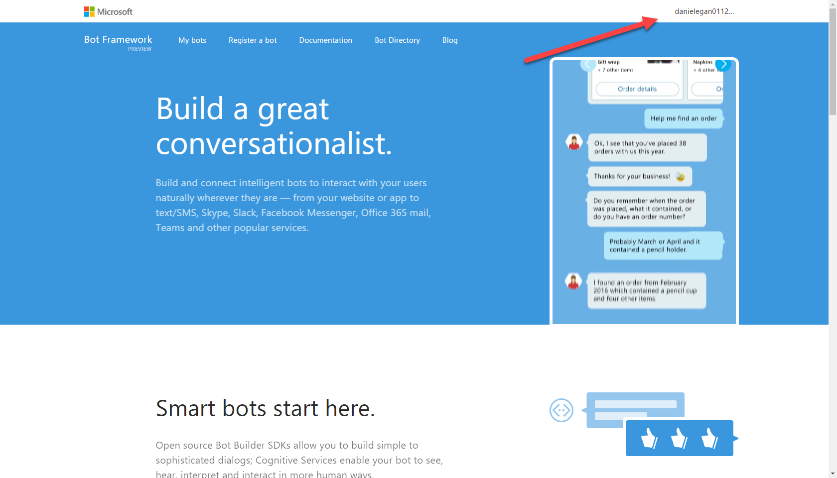
   * You can leave this window open, we will be using it later.
2. Sign-up for LUIS. Language Understanding Intelligent Services
   * <https://www.luis.ai/>
   * Click on: Sign in or Create Account button
   * Sign in with your Microsoft account   
       
     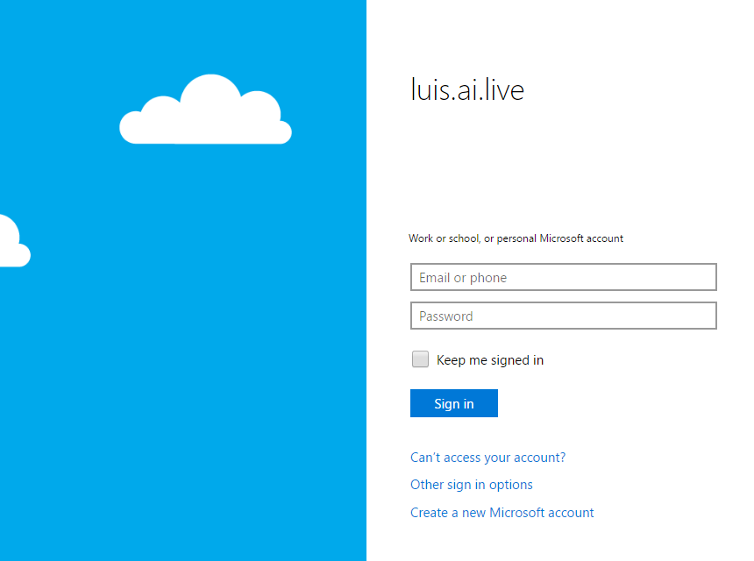
   * If you are still signed in it will ask you to say Yes to accept permissions. Otherwise you will need to sign in with the Microsoft ID you created earlier.  
       
     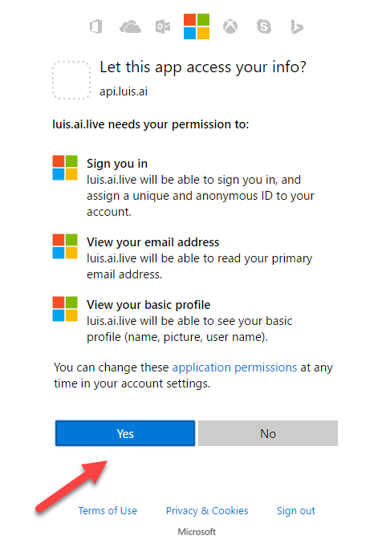
   * Fill out the required information (Put anything for company) and click Continue.   
       
     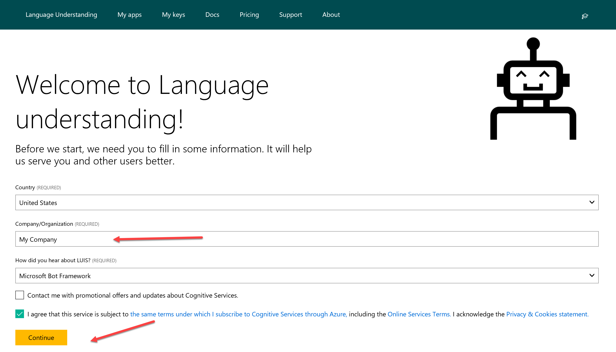  
       
       
     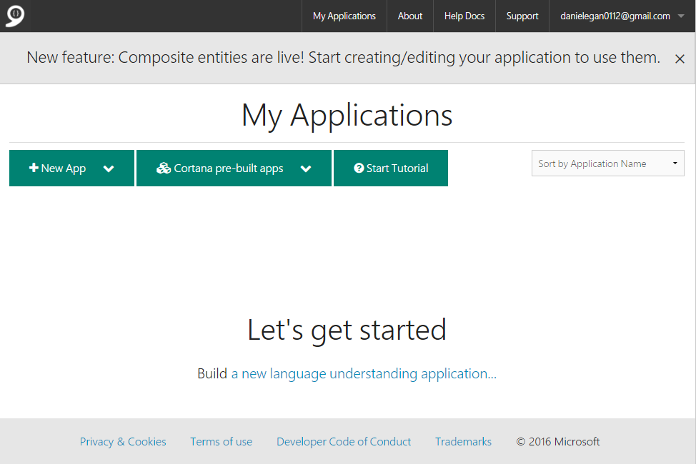
   * We will explain and use this later for our bot.

### Copy/Paste of Code

You will have the option to copy/paste code snippets from this document to complete this lab.  You will learn much more by typing it in yourself but sometimes in a lab format speed is needed to get through all the exercises in time.   
  
**NOTE**: If you are on a mac, you will be using the PDF file. Do not copy and paste from the PDF file. There is a separate file called SNIPSCSharp.txt that contain the snips you need.

## Exercise 1: Basic Bot using BotBuilder

In this exercise, you will create a simple bot using the bot framework C# teamplate and learn how rurn the emulator.

| **Detailed Steps** |
| --- |
| If you have not already don’t this in the prerequisites section, you will need to download and install the C# Bot Template. <http://aka.ms/bf-bc-vstemplate> (see instructions in prerequisites above)   1. Open or restart Visual Studio 2015 and go to File 🡪 New 🡪 Project Select the Bot Application Template and Name it DinnerBot    If you have used Web API previously, you will notice that the project that was set up is very similar to a WebApi project.   You can see both a MessagesController (which we will look at in a second) and a WebApiConfig. Let’s open up the WebApiConfig.cs    In here, among other things, you can see our routes set up as api/{controller}/{id}. This is going to map to api/messages (The MessagesController). You will notice this route not just in your project but also when we set this up on the BotFramework Portal.   Now let’s open up the MessagesController.cs  The first thing to notice is, as we discussed, it inherits from the ApiController . So any http Post to api/messages is routed to this method. Meaning all communication with your bot starts here. In addition, you can see it is being passed a type of Activity.   There are five different Activity Types.   C:\Users\danie\AppData\Local\Temp\Image.png  In this template, the main activity, message is handled here in the post. While all others are handled in the HandleSystemMessage below.   So once we know it’s a **Message** (1). We create a **ConnectorClient** (2) and pass it a **ServiceURL** (3) All the rest of this sample is doing is reading the message and saying it back to the user with the length of the characters by using the **ReplyToActivityAsync** method (4) .   We will be making changes to this bot but first we need to make sure that we can test it using the emulator. Make sure you have downloaded (<https://docs.botframework.com/en-us/downloads/> ) and installed it before you begin.   1. In Visual Studio, place a couple of breakpoints in the **MessagesController.cs** file so we can inspect things when we connect. 2. Hit **F5** or press the green arrow  to run your project.   When it launches, you will see the following in your browser of choice.    Notice that the bot will launch on localhost:3979 and gives you a reminder of your bots endpoint as well. If you wanted you could use tool like Paw, HTTPie, or Postman to test our endpoint but instead we will use the emulator. 3. Run the Bot Framework Channel Emulator that you previously installed.    When it launches, you will notice a few things.  1) A log which shows the ServiceURL that the emulator is listening on, as well as a note to install NGrok which will be needed later for using the emulator with a cloud hosted bot.   2) An ellipse menu that can be used to set up NGrok, create conversations, and send messages.  3) A prompt to enter the endpoint to your bot. 4. Click on the “Enter your endpoint URL” section to connect to your bot. 5. Enter the port that your bot launched on (Usually http://localhost:3979/api/messages)  notice that it is also asking for **Microsoft App ID** and **Microsoft App Password**. For testing locally, these are not needed. 6. Click on **CONNECT**. If all goes well, you should see 200 [ConversationUdate] in your log 7. Next, type Hello (or anything you want) into the txt field of the emulator.   Once you hit enter, you should hit the breakpoints you set in Visual Studio.     we are not going to walk through it, but take time to inspect the different values, properties and methods of the **Connector**, **Activity**, and **Message**.   When you are done, remove the breakponts and it **F5** to continure.   If you return back to the emulator, you will see the reponse from the bot (1), the entries in the log (2) and if you click on any of the post links, you will see the details associated with the request (3)    So in this section, we create a default hello world type of bot, got it up and running and interacted with in using the emulator. In the next section, we will start modifying it to create our dinner bot. |

## Exercise 2: Creating Dialogs

In this exercise, we will create a few simple dialogs in order to interact with the user.

| **Detailed Steps** |
| --- |
| 1. In your Solutions Explorer, right click on your project (DinnerBot) and select Add 🡪 New Folder    The first dialog we want to create is the RootDialog. This will be the place where all of our interaction flows. 2. Right click on the Dialogs Folder and select Add 🡪 Class and name it **RootDialog.cs**.     Once this comes up, we need to add a few using statements for the Bot. 3. Add the following using statements to the top of the **RootDialog.cs** file.   **----- SNIP1-----------------------------------**   using Microsoft.Bot.Builder.Dialogs;  using Microsoft.Bot.Connector;  using Microsoft.Bot.Builder.FormFlow;  Next, we need implement the IDialog Interface.   1. Add the IDialog<object> interface to the RootDialog class and implement the interface.    This will create a method called **StartAsync** which is what is called when we call the dialog. 2. The Bot Framework requires that classes must be serialized so the bot can be stateless. So add the serializable attribute to the top of the class. 3. Replace the default **NotImplementedException**   with the following code. Make sure you add the **async** keyword in front of Task in the method signature.  When this dialog is called, it will post back the message to the user. And then will wait for input form the user running any code in the **MessageRecievedAsync** method. 4. Next, we need to implement the MessageReceivedAsync method.    for now, we are just going to post another message to the user. Add the following code to the **MessageReceivedAsync** method and add the **async** attribute. 5. Add an **IMessageActivity** to the **IAwaitable**<> parameter. You will also need to add a **Microsoft.Bot.Connector** using statement as shown above.   Now we need to have the bot find this dialog. For this we need to modify the **MessageController** 6. In the Solution Explorer open up the Controllers 🡪 **MessagesController.cs** 7. Remove the following code in the **ActivityType.Message** if statement.     Replace with the following code. This tells the controller that if a message is received, route it to the **RootDialog**.     Make sure you add the **Microsoft.Bot.Builder.Dialogs** and **DinnerBot.Dialogs** using statements to the top of the file.    Let’s test our new dialog. 8. Hit **F5** or press the green arrow  to run your project. Make sure the browser launches. 9. Open up the emulator and click on the top bar to revel the last connection we used and select connect.   Once the emulator launches, type in hello and the bot will now use our first dialog (the root dialog).     Now that we have a root dialog, let’s do something besides just posting a simple message. We are going to give them an option to say hello or reserve a table. 10. First we need to create a **HelloDialog**. Right Click on the dialogs folder and create **HelloDialog.cs**  Making sure to: Add the **Microsoft.Bot.Builder.Dialogs** using statement Implement the **IDialog<>** interface,  Make the class **[Serializable]** Add the **async** qualifier to the **StartAsync** method (We will be pasting in the rest)  *(For detailed instructions refer back to creating the* **RootDialog** *above)* In the HelloDialog we are going to show how to save state to the state bag. 11. Inside you **HelloDialog.cs** file, place the following code inside the StartAsync method.     **----- SNIP2-----------------------------------**   //Greet the user  await context.PostAsync("Hey there, how are you?");  //call the respond method below  await Respond(context);  //call context.Wait and set the callback method  context.Wait(MessageReceivedAsync);  Now we need to implement the **Respond** and MessageReceivedAsync methods. We pass the **context** into the respond method and use it to check state, and ask their name for later use.   1. Paste the following code **below** the **StartAsync** Method    **----- SNIP3-----------------------------------**   private static async Task Respond(IDialogContext context)  {  //Variable to hold user name  var userName = String.Empty;  //check to see if we already have username stored  context.UserData.TryGetValue<string>("Name", out userName);  //If not, we will ask for it.  if (string.IsNullOrEmpty(userName))  {  //We ask here but dont capture it here, we do that in the MessageRecieved Async  await context.PostAsync("What is your name?");  //We set a value telling us that we need to get the name out of userdata  context.UserData.SetValue<bool>("GetName", true);  }  else  {  //If name was already stored we will say hi to the user.  await context.PostAsync(String.Format("Hi {0}. How can I help you today?", userName));  }  }   1. Now post the following code **below** the **Respond** method. In here we use the IMessageActivity that is passed in to capture what the user typed when we asked their name.     **----- SNIP4-----------------------------------**   public async Task MessageReceivedAsync(IDialogContext context, IAwaitable<IMessageActivity> argument)  {  //variable to hold message coming in  var message = await argument;  //variable for userName  var userName = String.Empty;  //variable to hold whether or not we need to get name  var getName = false;  //see if name exists  context.UserData.TryGetValue<string>("Name", out userName);  //if GetName exists we assign it to the getName variable and replace false  context.UserData.TryGetValue<bool>("GetName", out getName);  //If we need to get name, we go in here.  if (getName)  {  //we get the username we stored above. and set getname to false  userName = message.Text;  context.UserData.SetValue<string>("Name", userName);  context.UserData.SetValue<bool>("GetName", false);  }  //we call respond again, this time it will print out the name and greeting  await Respond(context);  //call context.done to exit this dialog and go back to the root dialog  context.Done(message);  }    The code is well commented, take your time to see how things are used in the dialog.   Now we want to wire up the **RootDialog** in order to send the user into the **HelloDialog**   1. Open up the **RootDialog.cs** file and add two strings to the top of the class to represent the choices.      **----- SNIP5-----------------------------------**   private const string ReservationOption = "Reserve Table";  private const string HelloOption = "Say Hello";  Now we want to use one of the built-in Dialogs. We will use the PromptDialog.Choice dialog to give them an option. We are going to prompt them right after they are greeted when they start a conversation.   1. Paste the following code inside the **MessageReceivedAsync** method in the **RootDialog.cs** file. This will let them choose between reserving a table or just saying hello.    **----- SNIP6-----------------------------------**   PromptDialog.Choice(  context,  this.OnOptionSelected,  new List<string>() { ReservationOption, HelloOption },  String.Format("Hi, are you looking for to reserve a table or Just say hello?"), "Not a valid option", 3);  This code passes in the context, sets a callback method (OnOptionSelected), defines a message when an invalid option is selected and limits try’s to 3. We will handle the try limit in the call back function. Let’s implement that now.   1. In the **RootDialog.cs** file place the following code below the **MessageReceivedAsync** method.      **----- SNIP7-----------------------------------**   private async Task OnOptionSelected(IDialogContext context, IAwaitable<string> result)  {  try  {  //capture which option then selected  string optionSelected = await result;  switch (optionSelected)  {  case ReservationOption:  break;  case HelloOption:  context.Call(new HelloDialog(), this.ResumeAfterOptionDialog);  break;  }  }  catch (TooManyAttemptsException ex)  {  //If too many attempts we send error to user and start all over.  await context.PostAsync($"Ooops! Too many attempts :( You can start again!");  //This sets us in a waiting state, after running the prompt again.  context.Wait(this.MessageReceivedAsync);  }  }  There are a couple of important parts of this code. If they selected the HelloOption then they will be sent to the **HelloDialog** by using **context.call**.     when it finishes that dialog it will return to the **ResumeAfterOptionsDialog** method as show in the code above so we will need to implement that method.   1. Paste the following code below the **OnOptionSelected** method in the **RootDialog.cs** file. In this code we are retrieving the message back from the Dialog (but doing nothing with it), capturing any errors coming back, and setting it ready for the user to communicate again with the call to context.wait.     **----- SNIP8-----------------------------------**   private async Task ResumeAfterOptionDialog(IDialogContext context, IAwaitable<object> result)  {  try  {  var message = await result;  }  catch (Exception ex)  {  await context.PostAsync($"Failed with message: {ex.Message}");  }  finally  {  context.Wait(this.MessageReceivedAsync);  }  }    Run your project and connect it to the emulator to test. (Detailed instructions if needed above) .  If you look at the code in the **HelloDialog** you can see the potential for unintended use, meaning we are not checking values, of confirming, or validating data. We could of course write all that by hand but we don’t need to. In the next exercise, we will use FormFlow to help us with this. |

## Exercise 3: Form Flow

In this exercise, we will be using FormFlow to create a dialog. There are a few ways to implement FormFlow, we will utilize prompts.

| **Detailed Steps** |
| --- |
| As we continue to work on the DinnerBot project, we will be modifying the project to work more closely with real world best practices. One of those, in the C# SDK, is the user of FormFlow. There are a few different ways to create FormFlows. We will utilize the separation of the model that the form flow follows, and the form itself. So to start we will need to create a couple of new folders.   1. Open up the DinnerBot project in Visual Studio and in the Solution Explorer, right click on the DinnerBot project and create two new folders called **Forms** and **Models** 2. Next right click on the **Models** Folder and and create class called **Reservation.cs**. 3. Add the **[Serializable]** attribute to the top of the class. 4. Add the following Using Statements to the top of the class.   **using Microsoft.Bot.Builder.FormFlow;**    You will notice that we do not need to implement the IDialog Interface for this class. FormFlow will take care of that for us.   We will be utilizing a few different techniques for things like validation to show the multiple ways of doing them and to show how flexible FormFlow is. We are essentially creating a class, with properties and methods, that FormFlow will use to create a conversation for us. In this case, it is for a reservation for a restaurant. Let’s get started by making some properties. 5. The first thing we need is to create an Enum to provide the ability for one of the answers from the questions to come from a list. Inside the class, paste the following code for Special Occasion selection.    **----- SNIP9-----------------------------------**   public enum SpecialOccasionOptions  {  Birthday,  Anniversary,  Engagement,  none  }   1. Next, we need to add a couple of properties for data we would like to collect from the user. Add the following properties below the enum.   **----- SNIP10-----------------------------------**   [Prompt(new string[] { "What is your name?" })]  public string Name { get; set; }  [Prompt(new string[] { "What is your email?" })]  public string Email { get; set; }  [Pattern(@"^(\+\d{1,2}\s)?\(?\d{3}\)?[\s.-]?\d{3}[\s.-]?\d{4}$")]  public string PhoneNumber { get; set; }  Let’s look at these individually. The first one is a simple string with a [Prompt] attribute that sets the question FormFlow will ask the user.     The second one is also a string to collect the email  The third one is a bit different, it uses a [Pattern] attribute to validate the phone number using a regular expression. We could have done that for the email as well but we will do that differently later on.   1. The next two properties will be for Reservation Date and Reservation Time. Paste them below the PhoneNumber property  **----- SNIP11-----------------------------------**   [Prompt("What date would you like to dine with us? example: today, tomorrow, or any date like 04-06-2017 {||}", AllowDefault = BoolDefault.True)]  [Describe("Reservation date, example: today, tomorrow, or any date like 04-06-2017")]  public DateTime ReservationDate { get; set; }  public DateTime ReservationTime { get; set; }  **ReservationDate** not only utilizes a **[Prompt]** attribute, but also a **[Describe]** attribute, which will be shown to the user if they type help during this FormFlow  **ReservationTime** on the other hand is just a property. It will still be validated to make sure that they give an answer that formats to a **DateTime**. That is part of the magic of FormFlow.     1. The final two properties are for **NumberOfDinners**, **SpecialOccasionOptions** (using the Enum) and Ratings to show that some can be optional. Paste the following code under the **ReservationTime** property.   **----- SNIP12-----------------------------------**   [Prompt("How many people will be joining us?")]  [Numeric(1, 20)]  public int? NumberOfDinners;  public SpecialOccasionOptions? SpecialOccasion;  [Numeric(1, 5)]  [Optional]  [Describe("for how you enjoyed your experience with Dinner Bot today (optional)")]  public double? Rating;     1. The last thing we want to add to this class is a constructor. Inside FormFlow you will not automatically have access to your current context or to data held in your userData. In our instance, we are already asking the user for their name, so we don’t want to ask them for it again when they are creating a reservation. You could easily pass in the entire context in, but we only need name so we pass it in the constructor and set the Name property to what is passed in.  Past the following code at the top of the class above the enum.   **----- SNIP13-----------------------------------**   public Reservation(string name )  {  this.Name = name;  }   1. Now we need to create the build form. Right click on the **Form** folder and create a class called **ReservationForm.cs** 2. Add the **[Serializable]** attribute to the top of the class. 3. Add the following Using Statements to the top of the class.   **using Microsoft.Bot.Builder.FormFlow; using Microsoft.Bot.Builder.FormFlow.Advanced; using System.Text.RegularExpressions;**   **using System.Threading.Tasks; using DinnerBot.Models;**   1. Inside the class, paste the following code.  **----- SNIP14-----------------------------------**   public static IForm<Reservation> BuildForm()  {  return new FormBuilder<Reservation>()  .Field(nameof(Reservation.Name))  .Field(nameof(Reservation.Email), validate: ValidateContactInformation)  .Field(nameof(Reservation.PhoneNumber))  .Field(nameof(Reservation.ReservationDate))  .Field(new FieldReflector<Reservation>(nameof(Reservation.ReservationTime))  .SetPrompt(PerLinePromptAttribute("What time would you like to arrive?"))  ).AddRemainingFields()  .Build();  }  We use the **IForm** of type **Reservation** to return a **FormBuilder**(of the same type).  We set the order for the first few fields, as you can see, we use a custom validator for the email as opposed to using the pattern like we did for phone. This gives us more flexibility. We can also set the prompt type per as you can see for the **ReservationTime** field. We then call **AddRemainingFields()** to pull in the rest. Finally, we call build.     1. Next, we add the validation code that we are using in the build. Paste the following code underneath the BuildForm() method. We won’t examine this since it is basic validation code.   **----- SNIP15-----------------------------------**   private static Task<ValidateResult> ValidateContactInformation(Reservation state, object response)  {  var result = new ValidateResult();  string contactInfo = string.Empty;  if (GetEmailAddress((string)response, out contactInfo))  {  result.IsValid = true;  result.Value = contactInfo;  }  else  {  result.IsValid = false;  result.Feedback = "You did not enter valid email address.";  }  return Task.FromResult(result);  }  private static bool GetEmailAddress(string response, out string contactInfo)  {  contactInfo = string.Empty;  var match = Regex.Match(response, @"[a-z0-9!#$%&'*+/=?^_`{|}~-]+(?:\.[a-z0-9!#$%&'*+/=?^_`{|}~-]+)*@(?:[a-z0-9](?:[a-z0-9-]*[a-z0-9])?\.)+[a-z0-9](?:[a-z0-9-]*[a-z0-9])?");  if (match.Success)  {  contactInfo = match.Value;  return true;  }  return false;  }  private static PromptAttribute PerLinePromptAttribute(string pattern)  {  return new PromptAttribute(pattern)  {  ChoiceStyle = ChoiceStyleOptions.PerLine  };  }   1. Now before we wire this up, we want to clean a few things up. The **HelloDialog** is doing more than just saying hello, it is also asking for a name and saving it. We want to abstract that out to its own dialog to hold User Info. Right-click on the Dialogs folder and **Add 🡪 Class** and call it **UserInfoDialog.cs** Making sure to: Add the following using statements **using** **Microsoft.Bot.Builder.Dialogs** ; **using** **Microsoft.Bot.Connector ;**  Implement the **IDialog<IMessageActivity>** interface,  Make the class **[Serializable]** Add the **async** qualifier to the **StartAsync** method (We will be pasting in the rest)  *(For detailed instructions refer back to creating the* **RootDialog** *above)  NOTE: Make sure the IDialog<> interface is using IMessageActivity and not Object* 2. In the StartAsync method paste the following code. Replacing the **throw new NotImplementedException();** **----- SNIP16-----------------------------------**   //Greet the user  await context.PostAsync("Before we begin, we would like to know who we are talking to?");  //call the respond method below  await Respond(context);  //call context.Wait and set the callback method  context.Wait(MessageReceivedAsync);   1. Next, we want to implement the **Respond()** method. Paste the following below the **StartAsync** method.  **----- SNIP17-----------------------------------**   private static async Task Respond(IDialogContext context)  {  //Variable to hold user name  var userName = String.Empty;  //check to see if we already have username stored  context.UserData.TryGetValue<string>("Name", out userName);  //If not, we will ask for it.  if (string.IsNullOrEmpty(userName))  {  //We ask here but dont capture it here, we do that in the MessageRecieved Async  await context.PostAsync("What is your name?");  //We set a value telling us that we need to get the name out of userdata  context.UserData.SetValue<bool>("GetName", true);  }  else  {  //If name was already stored we will say hi to the user.  await context.PostAsync(String.Format("Hi {0}. How can I help you today?", userName));  }  }     1. Now to complete the dialog, add the following **MessageReceivedAsync** method below StartAsync method.   **----- SNIP18-----------------------------------**   public async Task MessageReceivedAsync(IDialogContext context, IAwaitable<IMessageActivity> argument)  {  //variable to hold message coming in  try  {  var message = await argument;  //variable for userName  var userName = String.Empty;  //variable to hold whether or not we need to get name  var getName = false;  //see if name exists  context.UserData.TryGetValue<string>("Name", out userName);  //if GetName exists we assign it to the getName variable and replace false  context.UserData.TryGetValue<bool>("GetName", out getName);  //If we need to get name, we go in here.  if (getName)  {  //we get the username we stored above. and set getname to false  userName = message.Text;  context.UserData.SetValue<string>("Name", userName);  context.UserData.SetValue<bool>("GetName", true);  context.Wait(MessageReceivedAsync);  }  //await Respond(context);  context.Done(message);  }  catch (Exception ex)  {  string message = ex.Message;  }      }  Since we have already seen similar code in the **HelloDialog** we will not discuss it again here.   And speaking of the **HelloDialog**, we need to trim that a bit. Since we are gathering the name in the **UserInfoDialog**, all we need here is to say hi. Remove all except the following    We should be left with just two lines in the StartAsync as shown above. If you would like to just replace the contents of the class file, you can use the snip below. **----- SNIP19-----------------------------------**  using Microsoft.Bot.Builder.Dialogs;  using Microsoft.Bot.Connector;  using System;  using System.Threading.Tasks;  namespace DinnerBot.Dialogs  {  [Serializable]  public class HelloDialog : IDialog<object>  {  public async Task StartAsync(IDialogContext context)  {  //Greet the user  await context.PostAsync("Hey there, how are you?");    //call context.Done  context.Done<object>(null);  }  }  }    Now we want to go back to our Root Dialog and make some changes in order to call both our hello and our reservation dialogs. We want to set up some simple logic to check and see if we already know the name of the user and if not, call the **UserInfoDialog**.   1. Open up **RootDialog.cs** and go to the **MessageReceivedAsync** method. Add the following code (Replacing what is currently there)  **----- SNIP20-----------------------------------**   //check to see if we already have username stored  //If not, we will ask for it.  string userName = String.Empty;  var message = await result;  if (!context.UserData.TryGetValue<string>("Name", out userName))  {  context.Call(new UserInfoDialog(), ResumeAfterUserInfoDialog);  }  else  {  PromptUser(context);  }  In the code we are first checking to see if Name is already stored in **UserData**, if not we use **context.Call** to go into the UserInfoDialog and get the users name. Once we have the name we go back to prompt the user. Since we will be calling this from a few places we have abstracted that out to its own method called **PromptUser** so we need to implement that.   1. Right under the **StartAsync** method, add the following code.  **----- SNIP21-----------------------------------**   private void PromptUser(IDialogContext context)  {  PromptDialog.Choice(  context,  this.OnOptionSelected,  // Present two (2) options to user  new List<string>() { ReservationOption, HelloOption },  String.Format("Hi {0}, are you looking for to reserve a table or Just say hello?", context.UserData.Get<String>("Name")), "Not a valid option", 3);  }  This now interjects the name we saved into the prompt since we will always be asking the name first. We do that by having the **StartAsync** method always call the **MessageReceivedAsync** method with a **context.Wait()**.   1. Delete the await **context.PostAsync("Welcome to Dinner Bot" );** line from the **StartAsync** method so you are only left with **context.Wait(MessageReceivedAsync);** 2. The last thing we need to do for this section is to implement the **ResumeAfterUserInfoDialog**. Paste the following code below the **MessageReceivedAsync** Method   **----- SNIP22-----------------------------------**   private async Task ResumeAfterUserInfoDialog(IDialogContext context, IAwaitable<object> result)  {  PromptUser(context);  }  This will just call our PromptUser once it returns.    Now we want to update our **optionSelected** case statement inside of our **OnOptionSelected** method with the call to our **ReservationDialog.** We call this slightly differently since we are using Form Flow. In the context.Call, we pass it the Reservation with the name collected and saved in userData. Since we already asked them, we don’t want to ask again for reservations. We then call the BuildForm method of that dialog, and finally give it a call back method (which we will create shortly).   1. Paste the following code inside switch statement in the OnOptionsSelected method. This not only includes the new code we need to create the reservation form, but also a new callback method for the HelloOption which we will create next.   **----- SNIP23-----------------------------------**   case ReservationOption:  // Not implemented yet -- that's in the next lesson!  var form = new FormDialog<Reservation>(  new Reservation(context.UserData.Get<String>("Name")),  ReservationForm.BuildForm,  FormOptions.PromptInStart,  null);  context.Call(form, this.ReservationFormComplete);  break;  case HelloOption:  context.Call(new HelloDialog(), this.ResumeAfterUserHelloDialog);  break;    You will need to add the following using statements to the top of your file.   **using DinnerBot.Models;**  **using DinnerBot.Forms;**   We are almost there, we need to create two callback methods. One simple one for the new HelloDialog Callback and one for the Reservation Form callback. This is where we can see the results generated by the FormFlow.   1. First, we will create the method for the **HelloDialog** callback. This is going to be exactly the same as the callback for the **ResumeAfterUserInfoDialog**. Paste the following code above the **MessageReceivedAsync** Method.  **----- SNIP24-----------------------------------**   private async Task ResumeAfterUserHelloDialog(IDialogContext context, IAwaitable<object> result)  {  //we want it to go right to the prompting of reservation or hello  PromptUser(context);  }    2. Next paste the following code below the StartAsync method. It is a lot of code but we will walk through it after pasting.    **----- SNIP25-----------------------------------**   private async Task ReservationFormComplete(IDialogContext context, IAwaitable<Reservation> result)  {  try  {  var reservation = await result;  await context.PostAsync("Thanks for the using Dinner Bot.");  //use a card for showing their data  var resultMessage = context.MakeMessage();  //resultMessage.AttachmentLayout = AttachmentLayoutTypes.Carousel;  resultMessage.Attachments = new List<Attachment>();  string ThankYouMessage;  if (reservation.SpecialOccasion == Reservation.SpecialOccasionOptions.none)  {  ThankYouMessage = reservation.Name + ", thank you for joining us for dinner, we look forward to having you and your guests.";  }  else  {  ThankYouMessage = reservation.Name + ", thank you for joining us for dinner, we look forward to having you and your guests for the " + reservation.SpecialOccasion;  }  ThumbnailCard thumbnailCard = new ThumbnailCard()  {  Title = String.Format("Dinner Reservations on {0}", reservation.ReservationDate.ToString("MM/dd/yyyy")),  Subtitle = String.Format("at {1} for {0} people", reservation.NumberOfDinners, reservation.ReservationTime.ToString("hh:mm")),  Text = ThankYouMessage,  Images = new List<CardImage>()  {  new CardImage() { Url = "https://upload.wikimedia.org/wikipedia/en/e/ee/Unknown-person.gif" }  },  };  resultMessage.Attachments.Add(thumbnailCard.ToAttachment());  await context.PostAsync(resultMessage);  await context.PostAsync(String.Format(""));  }  catch (FormCanceledException)  {  await context.PostAsync("You canceled the transaction, ok. ");  }  catch (Exception ex)  {  var exDetail = ex;  await context.PostAsync("Something really bad happened. You can try again later meanwhile I'll check what went wrong.");  }  finally  {  context.Wait(MessageReceivedAsync);  }  }    We will start at the beginning of the method.  The **reservation** variable will hold the result of the form. After a quick prompt to the user, we create variables for the result message (we will use this to present a thumbnail card) and a variable for a thank you message.      The next section just creates a custom thank you message depending on whether or not they are having a special occasion using the reservation variable from above.  The final part (excluding the catches) creates a thumbnail card using the information from the form and posts it to the user.  Run your project and connect the emulator to test. If all works out fine, you should see the following when done.  In the next exercise, we are going to ties all of this up to **LUIS** to get Natural Language Processing as part of your bot. |

## Exercise 4: Using Intent Dialogs (LUIS)

In this exercise we will import a LUIS Model that will handle questions coming from the users and route them to the appropriate Dialogs. We will not be creating the model but importing an already existing model. If you would like to learn how to create your own model you can find great tutorials and walkthroughs here : <https://www.luis.ai/Help>

| **Detailed Steps** |
| --- |
| 1. Sign on to <http://www.LUIS.ai>. You should have set this up in the first exercise, if not go back to the first section. 2. From your dashboard Select **🡪 Import App** 3. Click Choose File to import the existing LUIS app. The file will be called **DinnerBot.json** and you will find it in the **BotWorkshop\CSharpWorkshop\** folder of the git repository you cloned.  Name it **DinnerBot** and click on import. 4. The next thing we need to do is train the model. Click on Train & Test on the left hand menu and then click on the Train Application button. 5. Once it is trained, we need to publish the model. On the left of the screen click on the Publish App link.   The first thing you need to do is add a key (if this not your first time using LUIS, your key will be found in the dropdown)   1. Hightlight and copy they key next to “Programmatic API Key:” Once you have that copied to your clipboard, Click on the Add a new key button 2. Paste the key into the Key Value box and click on save (you can optionally name it if you would like)     Click on MY Apps on the Top Bar and then click on the DinnerBot link to bring it up so we can publish it.    Next, click on Publish App in the left menu, select your key from the Endpoint Key dropdown, and click on the Publish button.       Leave the LUIS.ai website open, we will need some data from it in a moment.   Now we need to modify our RootDialog in order to have it work with LUIS. 3. Open the RootDialog.cs file and add the following Using statements to the top of the file. 4. Next, add the [LuisModel] attribute to the top of the class below the [Serializable] attribute  This will allow us to integrate with LUIS. We just need to add the **modelID** and Subscription key. We can get these from the LUIS.ai website. 5. Go back to the **LUIS.ai** website (Sign on if you need to) and open up your **DinnerBot** application. You will find the model ID and the subscription ID in right under where you clicked on publish.    In the Endpoint url, you will find the Model ID right after /apps/ in the url. The subscription key is… right after subscription-key. 6. Back in the **RootDialog.cs** file. Replace the strings modelID and **subscriptionKey** with the values you just retrieved. (Remember modelID is the same as App ID from LUIS website)      We also need to change the interface that our **RootDialog** inherits from. Change it from **IDialog**<> to **LuisDialog**<>   C:\Users\danie\AppData\Local\Temp\SNAGHTML4dc51150.PNG    Now we are ready to add our intents. This will fundamentally change how our RootDialog works. What we need when working with LUIS is methods that map (using attributes) to the intents form LUIS. So if we look at our Intents in LUIS, we need to map to the following Intents  In the **RootDialog.cs** file, remove the **StartAsync** method and replace it with the following code. One again, it’s a lot of code but we will step through it.   This code **REPLACES** the **StartAsync** method in RootDialog. We don’t need it since we are not implementing IDialog<>  **------SNIP26----------------------------------------------**  [LuisIntent("")]  [LuisIntent("None")]  public async Task None(IDialogContext context, LuisResult result)  {  string message = $"Sorry, I did not understand '{result.Query}'";  await context.PostAsync(message);  context.Wait(MessageReceived);  }  [LuisIntent("ReserveATable")]  public async Task ReserveATable(IDialogContext context, LuisResult result)  {  try  {  await context.PostAsync("Great, lets book a table for you. You will need to provide a few details.");  var form = new FormDialog<Reservation>(  new Reservation(context.UserData.Get<String>("Name")),  ReservationForm.BuildForm,  FormOptions.PromptInStart,  null);  context.Call(form, this.ReservationFormComplete);  }  catch (Exception)  {  await context.PostAsync("Something really bad happened. You can try again later meanwhile I'll check what went wrong.");  context.Wait(MessageReceived);  }  }  [LuisIntent("SayHello")]  public async Task SayHello(IDialogContext context, LuisResult result)  {  context.Call(new HelloDialog(), this.ResumeAfterOptionDialog);  }  [LuisIntent("Help")]  public async Task Help(IDialogContext context, LuisResult result)  {  await context.PostAsync("Insert Help Dialog here");  context.Wait(MessageReceived);  }  The first method has attributes that match a not found Luis Intent and one that is captured by None. Note that the result of this method is not a **LuisResult**. Also notice the **context.Wait**, the callback is **MessageReceived**. This is not something we write, but is part of the **LuisDialog**. It sets it ready for another Luis request.  Next is the main one the ReserveATable intent. The code inside here is exactly the same as we used in the last exercise except that it is arrived by someone asking LUIS instead of answering a prompt.     The last two implement the hello and help (which we did not implement)    That’s it, run your project and fire up the emulator. You can now try to ask for a reservation in different ways to see how LUIS handles it. Try things like “book a table” or “I need a table” if they don’t work, go back up to LUIS and train it some more to recognize additional statements. |

## Additional Resources

## Copyright

Information in this document, including URL and other Internet Web site references, is subject to change without notice and is provided for informational purposes only. The entire risk of the use or results from the use of this document remains with the user, and Microsoft Corporation makes no warranties, either express or implied. Unless otherwise noted, the companies, organizations, products, domain names, e-mail addresses, logos, people, places, and events depicted in examples herein are fictitious. No association with any real company, organization, product, domain name, e-mail address, logo, person, place, or event is intended or should be inferred. Complying with all applicable copyright laws is the responsibility of the user. Without limiting the rights under copyright, no part of this document may be reproduced, stored in or introduced into a retrieval system, or transmitted in any form or by any means (electronic, mechanical, photocopying, recording, or otherwise), or for any purpose, without the express written permission of Microsoft Corporation.

Microsoft may have patents, patent applications, trademarks, copyrights, or other intellectual property rights covering subject matter in this document. Except as expressly provided in any written license agreement from Microsoft, the furnishing of this document does not give you any license to these patents, trademarks, copyrights, or other intellectual property.

© 2009 Microsoft Corporation. All rights reserved.

Microsoft and Windows are trademarks of the Microsoft group of companies.

All other trademarks are property of their respective owners.